Colorectal HCP
Don’t include slides before pre test. Start with content only after pre-test
The burden ahead (projected, 2022 to 2050)
The graphs did not migrate.
Colon and rectal anatomy
Rectum and anal canal section should go before bowel wall.
Staging: the TNM system
This is not a myth or true/false section. It should not have x or checks on the description.
What screening is, and what it is not
Each image should go with the respective title and not merged. It is color coded for reference.
What screening is, and what it is not
Each image should go with the respective title and not merged. It is color coded for reference.
Screening programmes
“Core principle” bullet is not bulleted. Please make it part of the bulleted list.
Benefits and limitations
Benefits boxes were color coded green and limitations boxes were color coded red. Given that the populated info was not color coded, I created in the slides 2 different titles in the PPT for both EN and FR. Benefits. Limitations. Make sure green boxes populate in the benefits section and reds in the limitations section.
How urgently to refer
Each image should go with the respective title and not merged. It is color coded for reference.
What to record at first contact
Increase the size of the image
Colonoscopy has three different jobs
The item “The endoscopist can see the lining of the colon and rectum directly, describe the site and size of a lesion, take biopsies, remove suitable polyps completely, and mark a lesion so a surgeon can find it later.” should be the first box and not the fourth one.
Imaging and staging
The item “Which tests: Contrast-enhanced computed tomography of the chest and multiphasic computed tomography of the abdomen. For rectal cancer, add contrast-enhanced magnetic resonance imaging of the pelvis.” should be the first box and not the last one.
Match the clue to the next step
Although the option is correct, there was a part of the sentence that was deleted and should be included again for the Chemotherapy
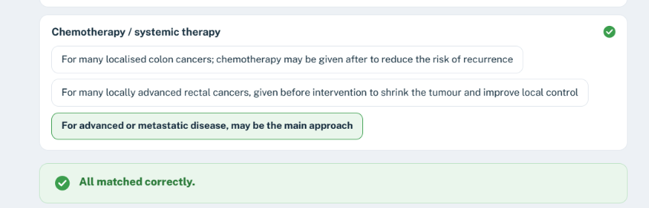
Full response should be: For advanced or metastatic disease may be the main approach. Treatment is selected according to tumour characteristics, disease extent and patient fitness.
Treatment: removing the disease
The image from endoscopic removal populated on stoma and emergency surgery section incorrectly.
Treatment: radiotherapy
First image should not be there
Treatment: targeted therapy and immunotherapy
The item “New treatments are not standard for most colorectal cancers, nor are they alternatives to surgery for early-stage disease.” should be the first box and not the fourth one.
Stoma
Increase the size of the image
Palliative care
Increase the size of the image
Quality of life
Increase the size of the image
Follow-up after treatment
Increase the size of the image

